# Final Report: Waste Classification Using ResNet

## 1. Introduction

This project focuses on implementing a deep learning-based waste classification system using ResNet. The model aims to assist in automated sorting for waste management, classifying images into 30 distinct categories. The enhanced ResNet model achieved an accuracy of 84% on the test set.

## 2. Dataset

The [dataset](https://www.kaggle.com/datasets/alistairking/recyclable-and-household-waste-classification) was sourced from the `waste_dataset/images/images` directory. It contains 30 classes, including aerosol cans, aluminum food cans, and plastic bags, among others. The data was split into:

- Training set: 70% of the data.

- Validation set: 15% of the data.

- Test set: 15% of the data.

Dataset Preprocessing

- Image Size: Resized to 224 × 224 pixels.

- Normalization: Standardized using the following transformations:

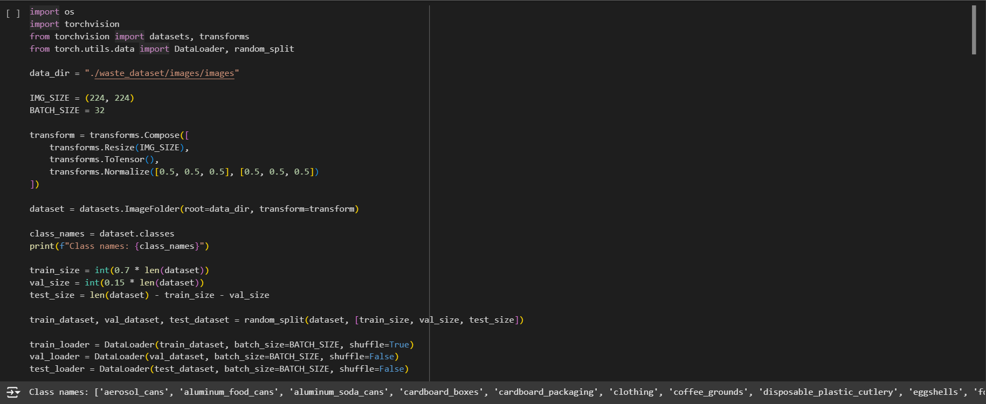

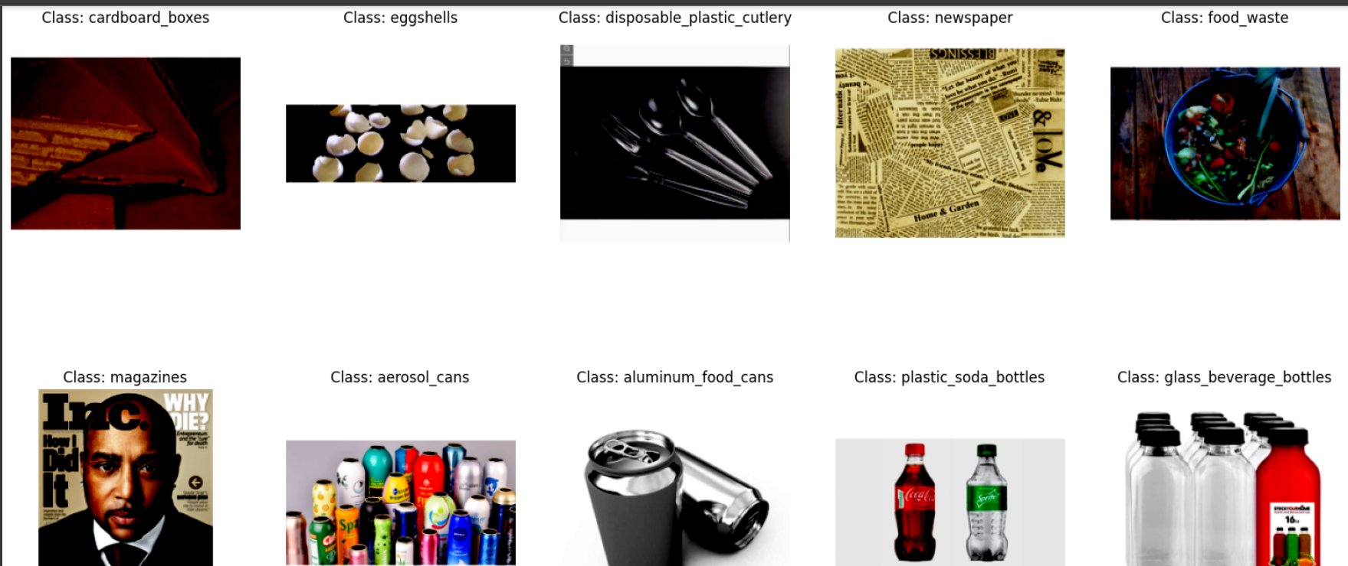

## 3. Model Training

3.1 Initial Model

The base model was ResNet18, pre-trained on ImageNet. Its final fully connected layer was modified to output 30 classes:

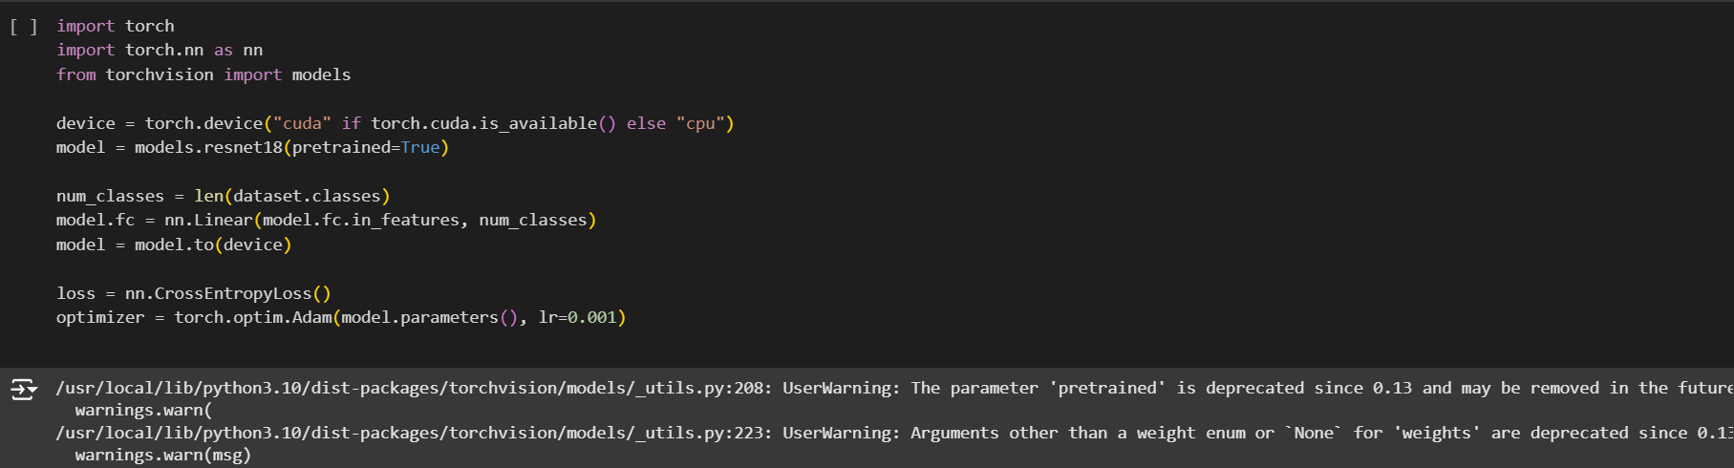

3.2 Enhanced Model

The enhanced model includes additional regularization via a dropout layer and a fully connected intermediate layer with ReLU activation:

3.3 Training Configuration

- Loss Function: CrossEntropyLoss for multi-class classification.

- Optimizer: Adam with learning rates:

- Base model: 0.001.

- Enhanced model: 0.0001.

- Batch Size: 32.

- Epochs: 5.

- Learning Rate Scheduler: Decayed learning rate during training to improve convergence.

Training results for the baseline model:

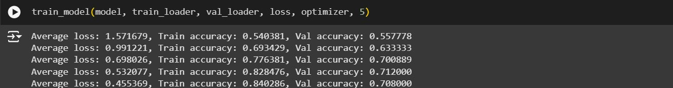

Training results for the enhanced model:

## 4. Model Evaluation

Both models were evaluated on the test set. Detailed metrics are provided below

Baseline model:

- Precision (Macro Average): 75%

- Recall (Macro Average): 72%

- F1-Score (Macro Average): 72%

- Accuracy: 72%.

Classification Metrics

- Precision (Macro Average): 84%

- Recall (Macro Average): 83%

- F1-Score (Macro Average): 83%

- Accuracy: 84%.

The detailed classification report:

Baseline model:

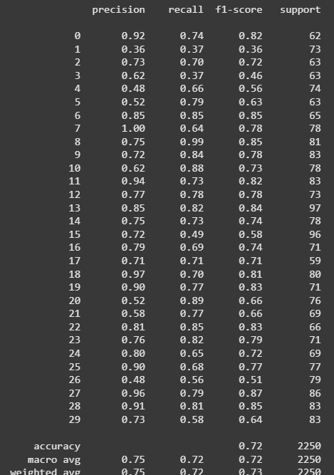

Enhanced model:

## 5. Code and Repository

Link to GitHub: <https://github.com/adlrkbln/waste_classification>

## 6. Conclusion

The enhanced ResNet model demonstrated substantial improvement over the baseline, achieving an 84% accuracy on the test dataset. The deployment interface further showcases its practical utility.